**Linux Basics assignment**

1. Creating and Renaming Files/Directories

Q. Create a directory named test_dir using mkdir.

Answer:: 

Q. Inside test_dir, create an empty file called example.txt.

Answer:: 

Q. Rename example.txt to renamed_example.txt using mv

Answer:: 



2. Viewing File Contents

Q. Use cat to display the contents of /etc/passwd.

Answer:: 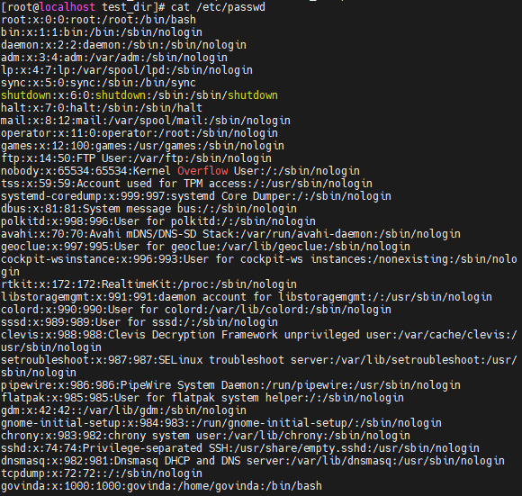

Q. Display only the first 5 lines of /etc/passwd using head.

Answer:: 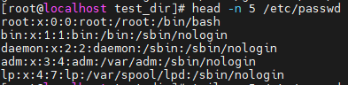

Q. Display only the last 5 lines of /etc/passwd using tail.

Answer:: 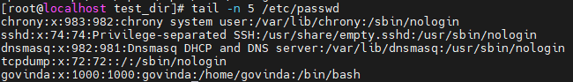

3.Searching for Patterns

Q. Use grep to find all lines containing the word "root" in /etc/passwd.

Answer:: 

4. Zipping and Unzipping

Q. Compress the test_dir directory into a file named test_dir.zip using zip.

Answer:: 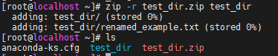

Q. Unzip test_dir.zip into a new directory named unzipped_dir.

Answer:: 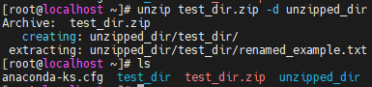

5. Downloading Files

Q. Use wget to download a file from a URL (e.g., <https://example.com/sample.txt>).

Answer:: 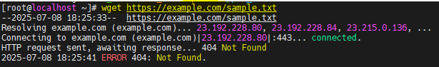

6. Changing Permissions

Q. Create a file named secure.txt and change its permissions to read-only for everyone using chmod.

Answer:: 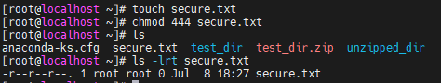

7. Working with Environment Variables

Q.Use export to set a new environment variable called MY_VAR with the value "Hello, Linux!"

Answer:: 